Wireshark TCP/UDP
Lecturer: Nguyễn KHánh Thuật

Huỳnh ÂN | 24560064 | 24560064@gmail.uit.edu.vn

Wireshark TCP:
- What is the IP address and TCP port number used by the client computer (source) that is transferring the alice.txt file to gaia.cs.umass.edu?
Answer: The IP address is the Source(Src) of HTTP message in line 153, which are 192.168.86.68 and the TCP port number is 55639. The information is found in the Internet Protocol Version 4 and Transmission Control Protocol sections of the captured trace.
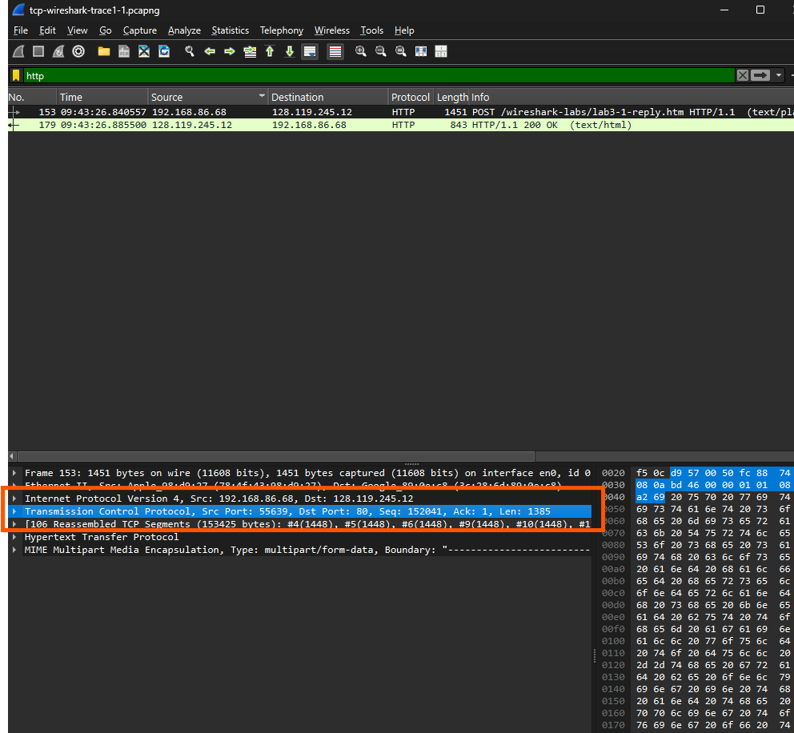
- What is the IP address of gaia.cs.umass.edu? On what port number is it sending and receiving TCP segments for this connection?
Answer: The IP address of gaia.cs.umass.edu is 128.119.245.12 and the TCP port number is 80.
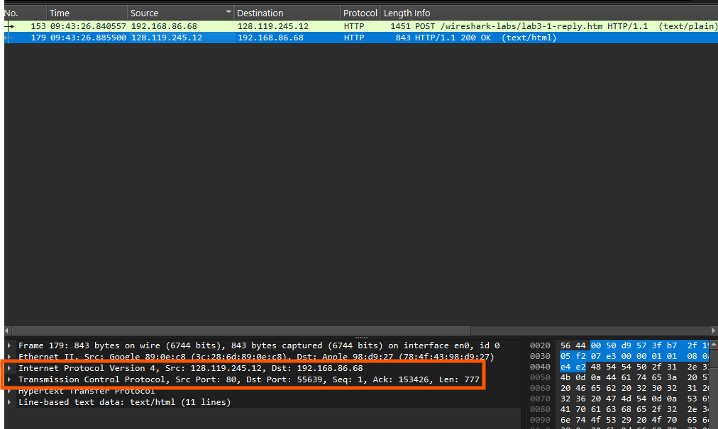
- What is the sequence number of the TCP SYN segment that is used to initiate the TCP connection between the client computer and gaia.cs.umass.edu? (Note: this is the “raw” sequence number carried in the TCP segment itself; it is NOT the packet # in the “No.” column in the Wireshark window. Remember there is no such thing as a “packet number” in TCP or UDP; as you know, there are sequence numbers in TCP and that’s what we’re after here. Also note that this is not the relative sequence number with respect to the starting sequence number of this TCP session.). What is it in this TCP segment that identifies the segment as a SYN segment? Will the TCP receiver in this session be able to use Selective Acknowledgments (allowing TCP to function a bit more like a “selective repeat” receiver, see section 3.4.5 in the text)?
Answer: The raw sequence number of the TCP SYN segment is 4236649187 in Transmission Control Protocol of the captured trace, which is used to initiate the TCP connection. Recognizing the difference of SYN segment with the remaining ones by checking the Flags in Transmission Control Protocol if the part Syn is set. Also, the “SYN” can be seen on the Info of Wireshark Window.The TCP receiver in this session is able to use Selective Acknowledgments(SACK) because the SACK is permitted and this information is found in the Options of Transmission Control Protocol.
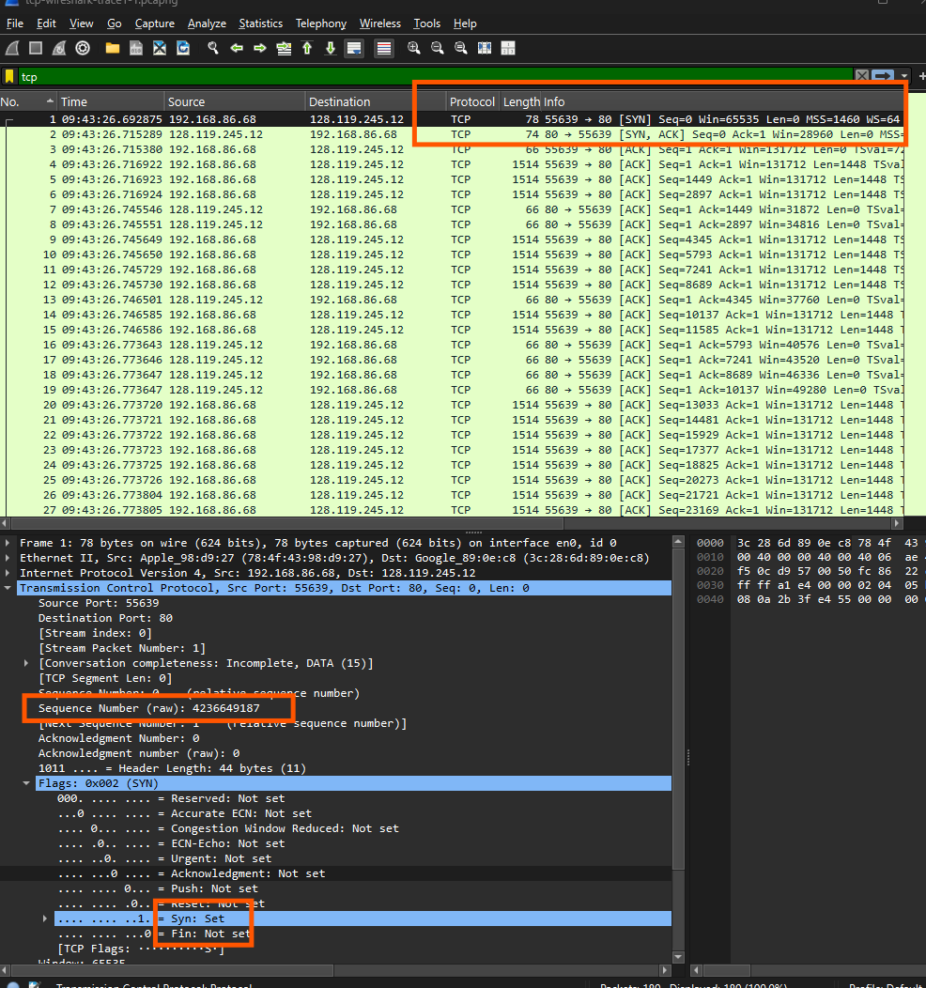
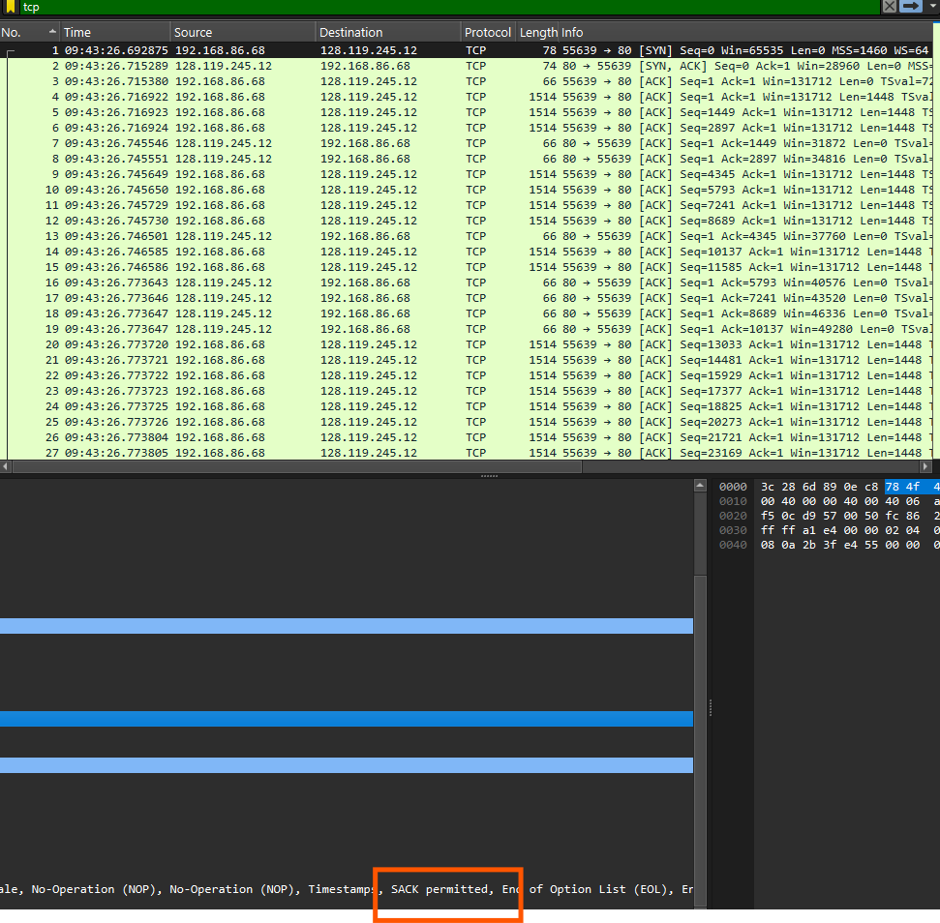
- What is the sequence number of the SYNACK segment sent by gaia.cs.umass.edu to the client computer in reply to the SYN? What is it in the segment that identifies the segment as a SYNACK segment? What is the value of the Acknowledgement field in the SYNACK segment? How did gaia.cs.umass.edu determine that value?
Answer: The raw sequence number of the SYNACK segment is 1068969752 in Transmission Control Protocol of the captured trace. Recognizing the difference of SYNACK segment with the remaining ones by checking the Flags in Transmission Control Protocol if the Syn and Ack are set. Also, the “SYN”and the “ACK”can be seen on the Info of Wireshark Window. The value of the Acknowledgement field in the SYNACK segment is 4236649188 and gaia.cs.umass.edu determine the value by set its acknowledgement number to $x+1$, so the TCP uses an acknowledgement system will receive byte + 1 .
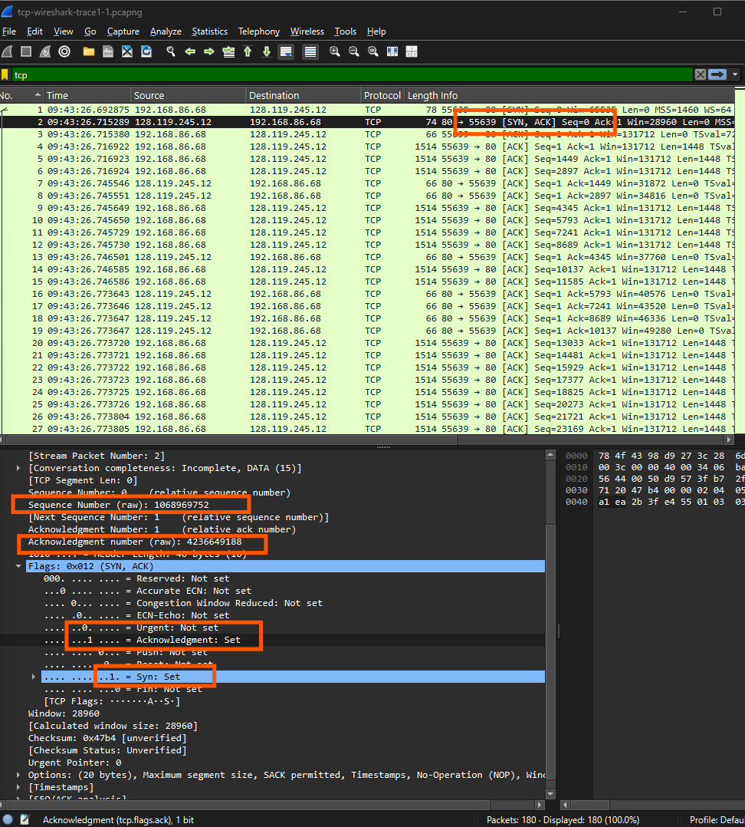

- What is the sequence number of the TCP segment containing the header of the HTTP POST command? Note that in order to find the POST message header, you’ll need to dig into the packet content field at the bottom of the Wireshark window, looking for a segment with the ASCII text “POST” within its DATA field4,5. How many bytes of data are contained in the payload (data) field of this TCP segment? Did all of the data in the transferred file alice.txt fit into this single segment?
Answer: The sequence number of the TCP segment containing the header of the HTTP POST command is 4236649188. There are 1448 bytes of data in the TCP payload abd all of data in the transferred file alice.txt do not fit into this single segment because the Content-Length: 152359.
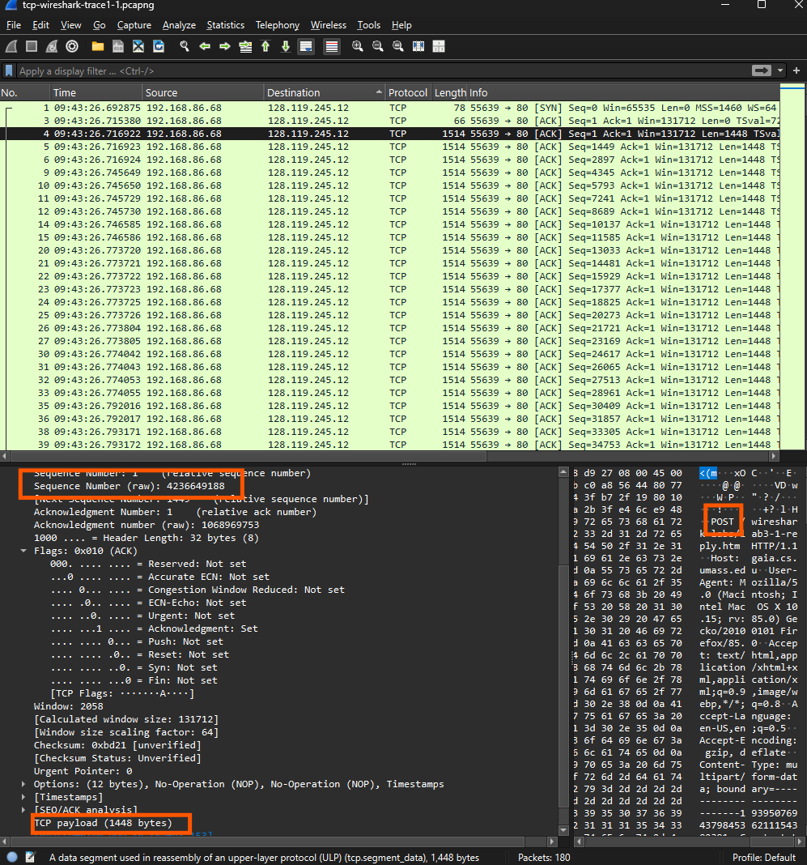
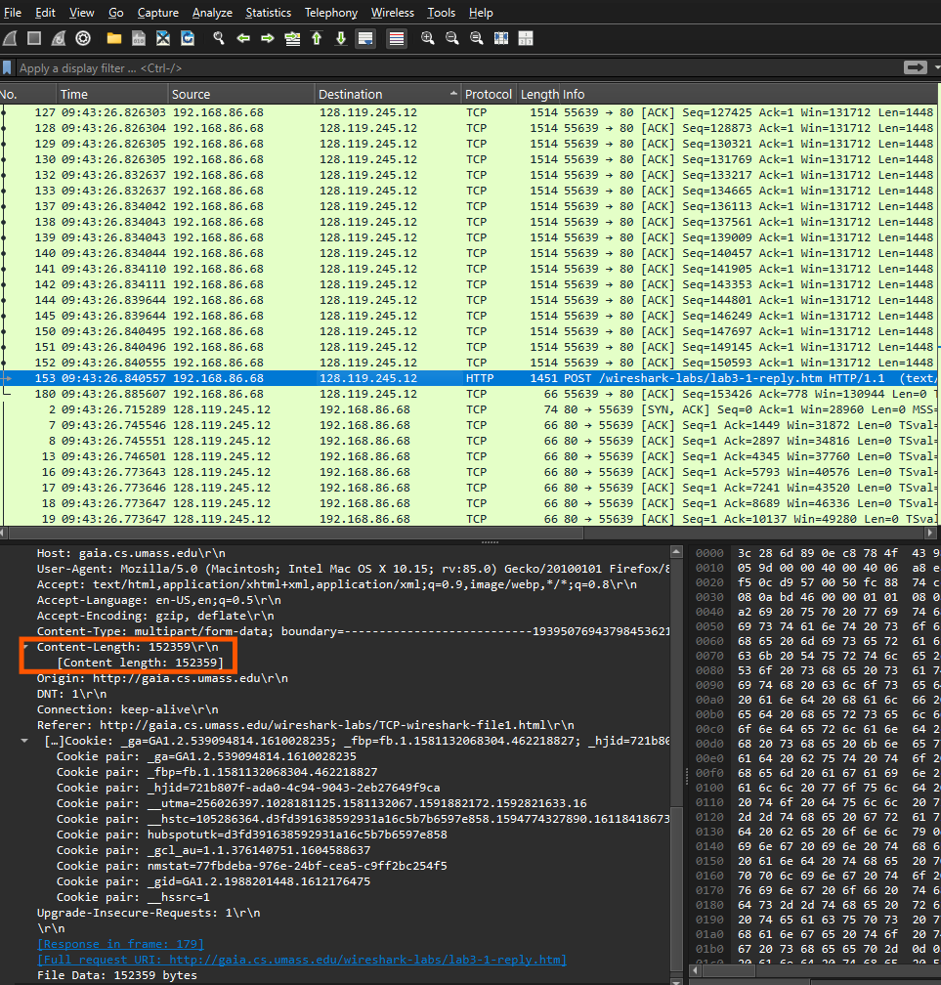
- Consider the TCP segment containing the HTTP “POST” as the first segment in the data transfer part of the TCP connection.
• At what time was the first segment (the one containing the HTTP POST) in the data-transfer part of the TCP connection sent?
• At what time was the ACK for this first data-containing segment received?
• What is the RTT for this first data-containing segment?
• What is the RTT value the second data-carrying TCP segment and its ACK?
• What is the EstimatedRTT value (see Section 3.5.3, in the text) after the ACK for the second data-carrying segment is received? Assume that in making this calculation after the received of the ACK for the second segment,that the initial value of EstimatedRTT is equal to the measured RTT for the first segment, and then is computed using the EstimatedRTT equation on page 242, and a value of α = 0.125.
• Answer: The time when the first segment of the HTTP POST was sent:
+ Arrival Time: Feb 3, 2021 09:43:26.716922000 SE Asia Standard Time
+ UTC Arrival Time: Feb 3, 2021 02:43:26.716922000 UTC
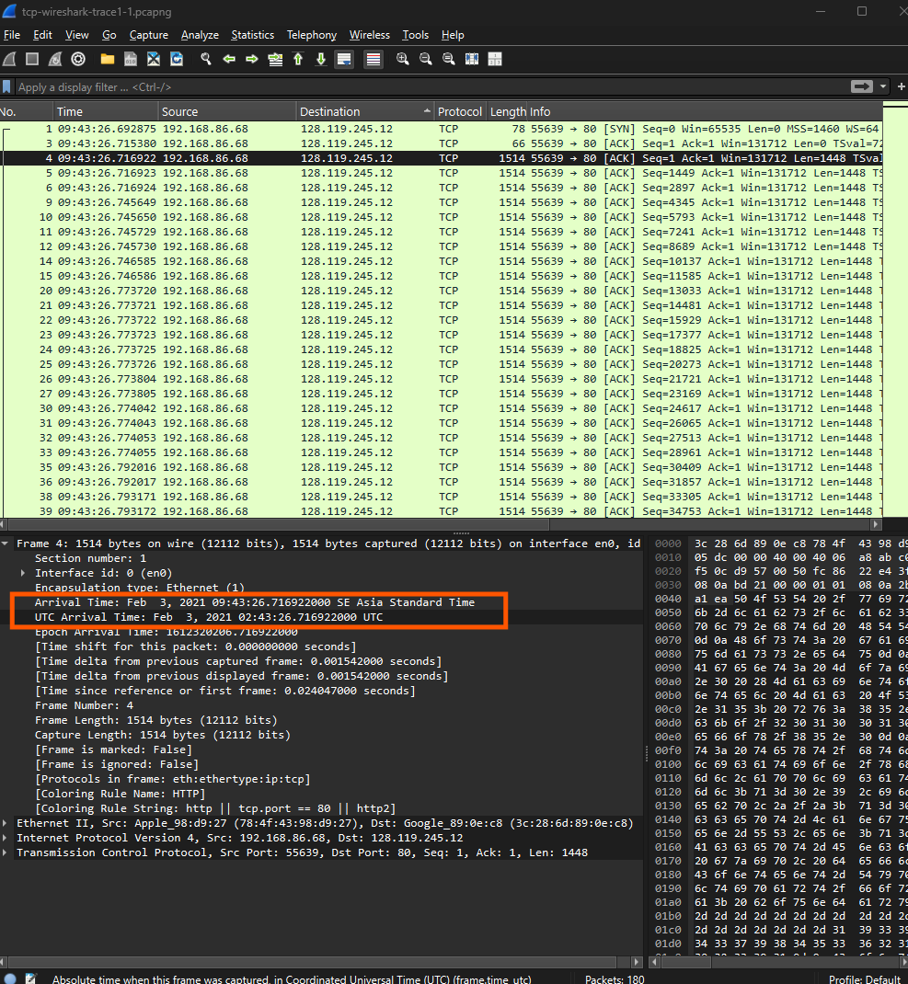
• Answer:The time when the ACK for this first data-containing segment was received:
+ Arrival Time: Feb 3, 2021 09:43:26.745546000 SE Asia Standard Time
+ UTC Arrival Time: Feb 3, 2021 02:43:26.745546000 UTC
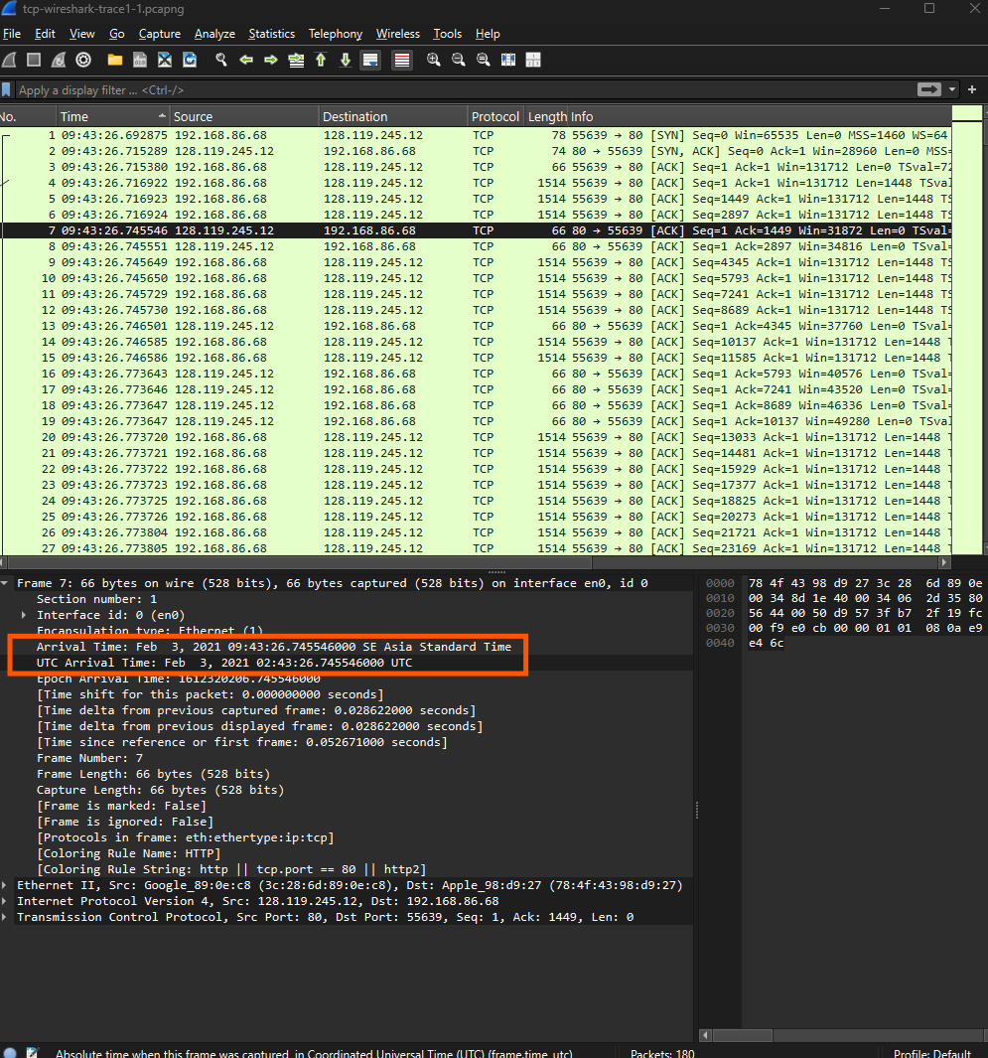
• Answer: The RTT is $09:43:26.745546000−09:43:26.716922000=0.028624$000 second. Additionally,the RTT to ACK the segment shown in the Transmission Control Protocol instead of compute by hand.
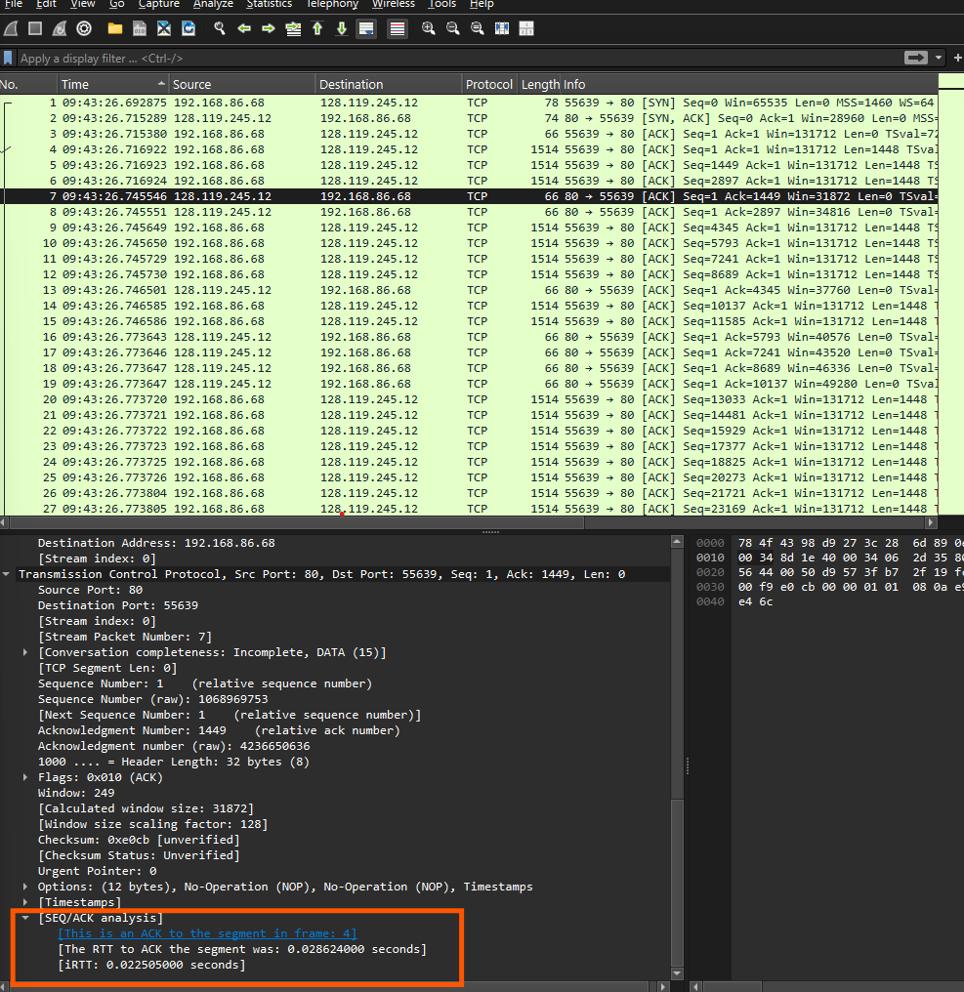
• Answer:the RTT value the second data-carrying TCP segment and its ACK is 0.028628000
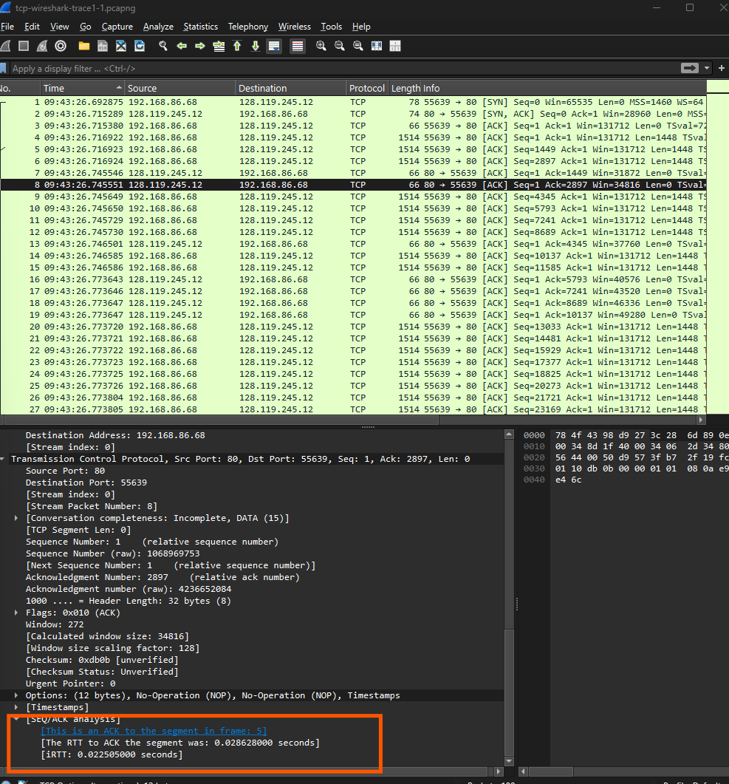
• Answer: The formula of EstimatedRTT:
$$EstimatedRTT=(1−α)×EstimatedRTT_{previous}+α×SampleRTT$$
the EstimatedRTT value after the ACK for the second data-carrying segment is received:
$$EstimatedRTT=(1−0.125)×0.028624+0.125×0.028628=0.0286245$$
- What is the length (header plus payload) of each of the first four data-carrying TCP segments?
Answer: The length of each of the first four data-carrying TCP segments is 1480 ( Header Length in Internet Protocol is 32 bytes and the TCP payload in Transmission Control Protocol is 1448).
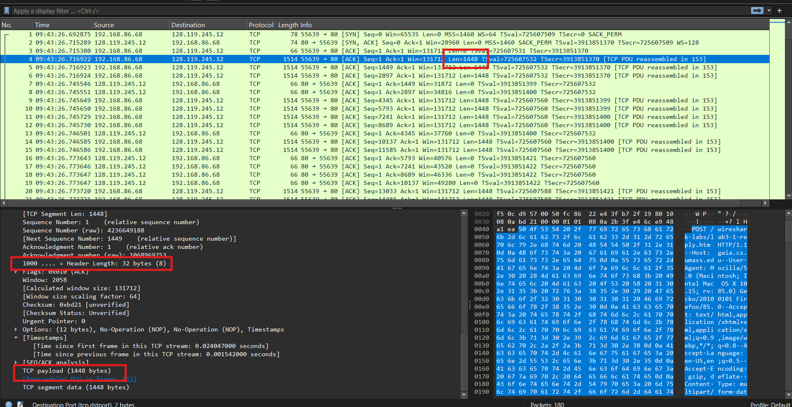
- What is the minimum amount of available buffer space advertised to the client by gaia.cs.umass.edu among these first four data-carrying TCP segments7? Does the lack of receiver buffer space ever throttle the sender for these first four data carrying segments?
Answer: Minimum buffer space provided by gaia.cs.umass.edu to client among these first four data-carrying TCP segments is 249. We never have any receiver buffer space to fall behind and throttle the sender for these first four data carrying segments since we never utilize to capacity.
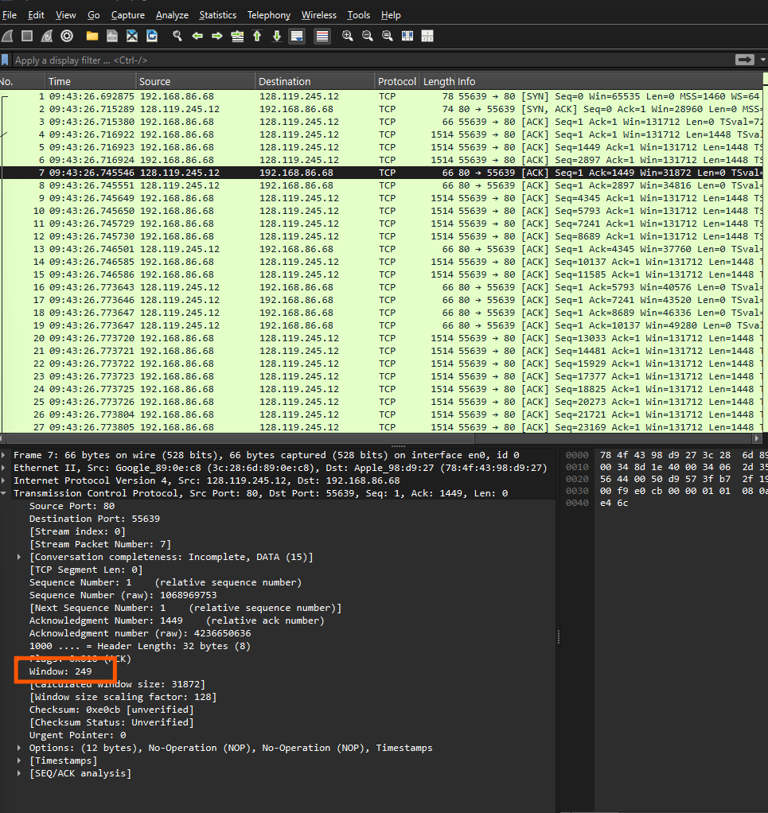
- Are there any retransmitted segments in the trace file? What did you check for (in the trace) in order to answer this question?
Answer: There are not any retransmitted segments in the trace file. To explain how to check there are any retransmitted segments available, let’s first look at Info column of Wireshark window and check if any segment are marked as TCP Restransmission or check the sequence number of segment if the serial number appears twice.
- How much data does the receiver typically acknowledge in an ACK among the first ten data-carrying segments sent from the client to gaia.cs.umass.edu? Can you identify cases where the receiver is ACKing every other received segment (see Table 3.2 in the text) among these first ten data-carrying segments?
Answer: There are typically 1448 bytes acknowledge in an ACK among the first ten data-carrying segments when the receiver sent from the cilent to gaia.cs.umass.edu. Based on the packet capture in Wireshark, to solve the problem of how much data the receiver (gaia.cs.umass.edu, 128.119.245.12) acknowledges in an ACK in the first 10 data segments received by the client (192.168.86.68) and whether there are occurrences of acknowledging every other segment, the following steps are taken. Second, the series of ACKs from the receiver (128.119.245.12) to the client (192.168.86.68) from No. 7 after or among the 10 data segments (No. 4, 5, 6, 9, 10, 11, 12, 14, 15, 20) are: No. 7 (Ack=1449, Win=31872), No. 8 (Ack=2897, Win=34816), No. 13 (Ack=4345, Win=37760), No. 16 (Ack=5793, Win=40576), No. 17 (Ack=7241, Win=43520), No. 18 (Ack=8689, Win=46336), No. 19 (Ack=10137, Win=49280), No. 28 (Ack=11585, Win=52224),No. 29 (Ack=13033, Win=55040),and No. 34 (Ack=14481, 57984) are mentioned as they are acknowledging data within the scope of the first 10 data segments. Then, the data accepted in each ACK is determined: No. 7 (Ack=1449) receives 1448 bytes (No. 4), No. 8 (Ack=2897) receives 1448 bytes (No. 5), No. 13 (Ack=4345) receives 1448 bytes (No. 6), No. 16 (Ack=5793) receives 1448 bytes (No. 9), No. 17 (Ack=7241) receives 1448 bytes (No. 10), No. 18 (Ack=8689) receives 1448 bytes (No. 11), No. 19 (Ack=10137) receives 1448 bytes (No. 12), No. 28 (Ack=11585) receives 1448 bytes (No. 14), No. 29 (Ack=13033) receives 1448 bytes (No. 15), and No. 34 (Ack=14481) receives 1448 bytes (No. 20). Every ACK is acknowledging 1448 bytes, and they match with 1 data segment, so there are 1448 bytes per ACK on average. Then the situation of acknowledging all other segments (delayed ACK, i.e., acknowledging two consecutive segments) is attempted: No. 7 acknowledges No. 4 (1448 bytes), No. 8 acknowledges No. 5 (1448 bytes), No. 13 acknowledges No. 6 (1448 bytes), No. 16 acknowledges No. 9 (1448 bytes), No. 17 acknowledges No. 10 (1448 bytes), No. 18 acknowledges No. 11 (1448 bytes), No. 19 acknowledges No. 12 (1448 bytes), No. 28 acknowledges No. 14 (1448 bytes), No. 29 acknowledges No. 15 (1448 bytes), and No. 34 acknowledges No. 20 (1448 bytes). There are no later ACKs in the list that fulfill the conditions to acknowledge the following packets. No ACK is acknowledging two segments in a row since each ACK is acknowledging only 1 segment (1448 bytes). Conclusion: The receiver is acknowledging 1448 bytes (1 segment) in an ACK. There are no cases where the receiver is acknowledging every other segment (delayed ACK).
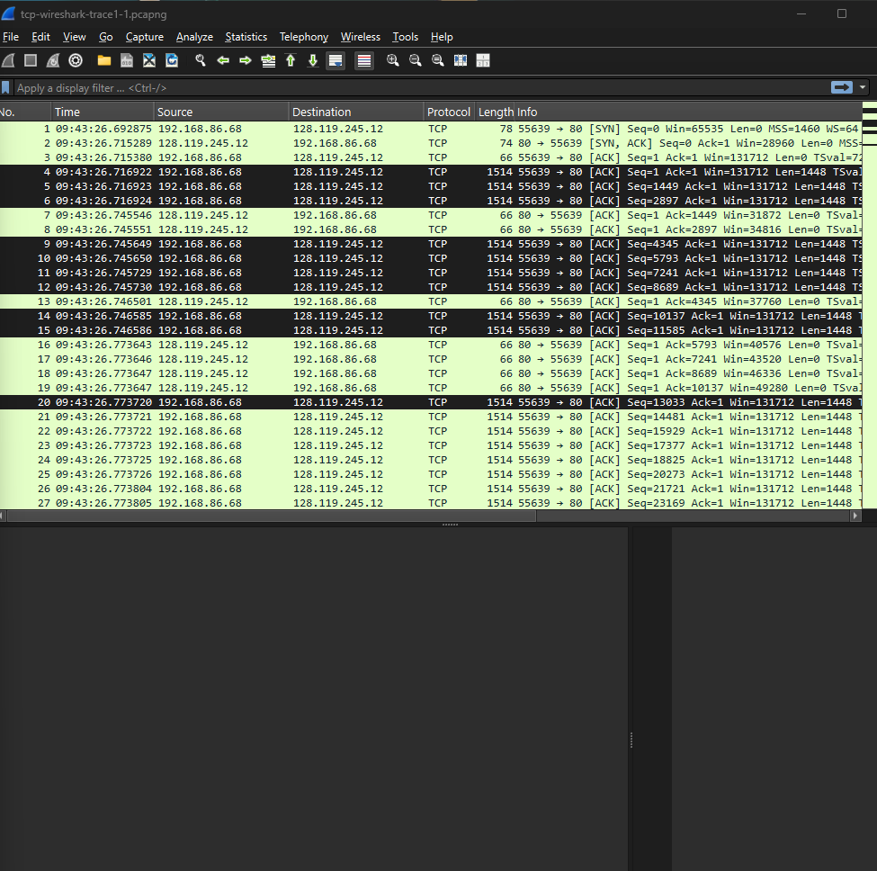
- What is the throughput (bytes transferred per unit time) for the TCP connection? Explain how you calculated this value.
Answer: The throughput for the TCP connection is approximately 1240 kB/s. I got this result by dividing the total bytes of data (153425 bytes from Reassembled TCP Segments of Transmission Control Protocol in segment 153, which is the HTTP POST) by the transmission time between the first segment was sent and the final segment($26.840555−26.716922=0.123633 (s)$)
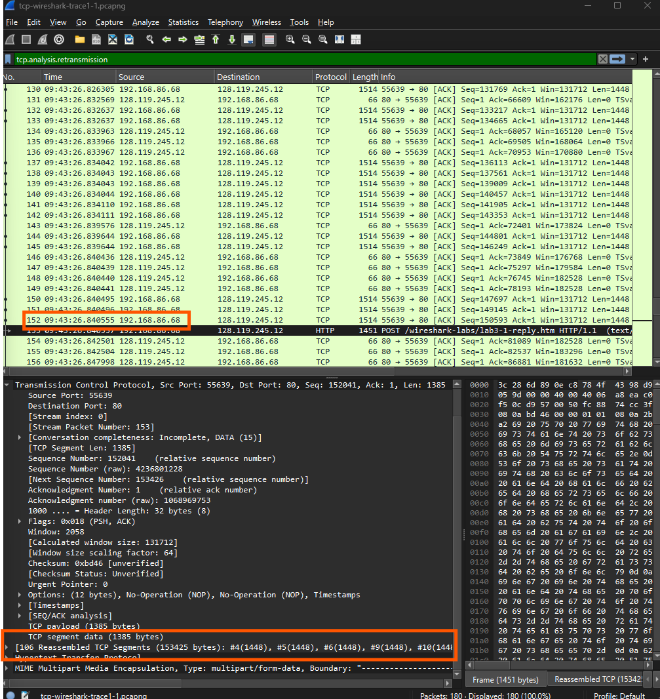
- Use the Time-Sequence-Graph(Stevens) plotting tool to view the sequence number versus time plot of segments being sent from the client to the gaia.cs.umass.edu server. Consider the “fleets” of packets sent around t = 0.025, t = 0.053, t = 0.082 and t = 0.1. Comment on whether this looks as if TCP is in its slow start phase, congestion avoidance phase or some other phase. Figure 6 shows a slightly different view of this data.
Answer: Based on the Time-Sequence_Graph(Stevens),every fleet at the point are t=0.025, 0.053, 0.082, 0.1 respectively, indicating an increasse exponentially of packet per fleet. Thus,Time-Sequence-Graph is in the slow start phase.(3->6->12)
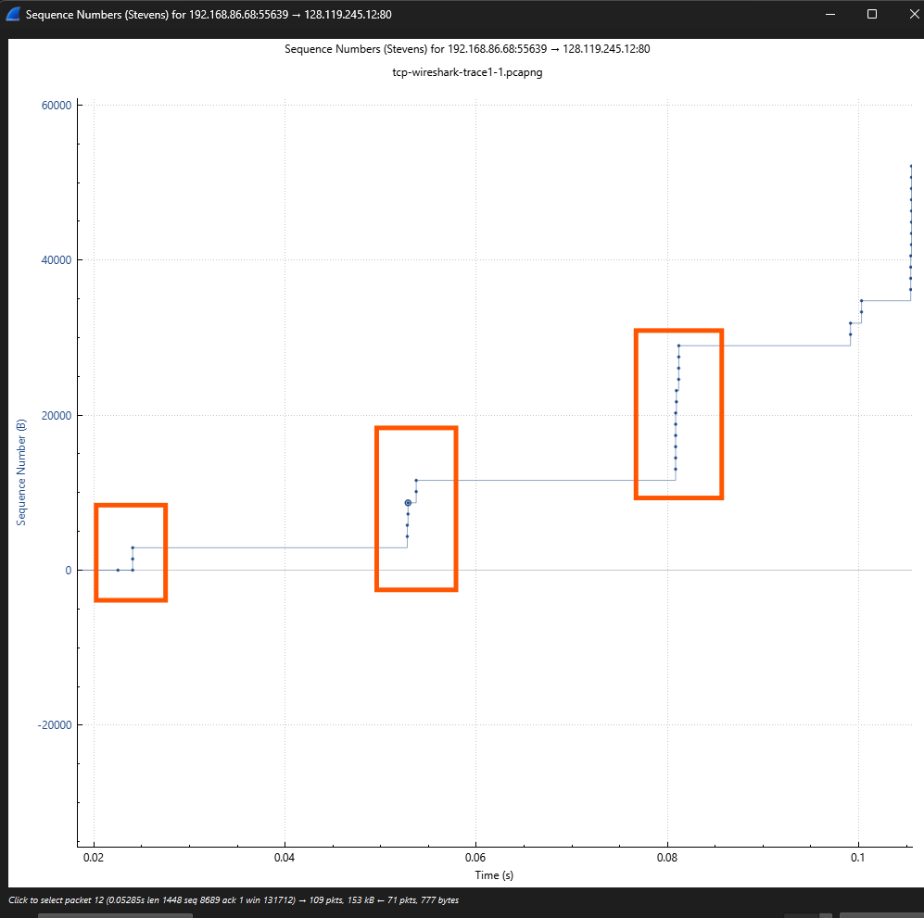
- These “fleets” of segments appear to have some periodicity. What can you say about the period?
Answer: The fleets of segments at = 0.025, 0.053, 0.082, and 0.1 have an average cycle of approximately 0.025 seconds. This periodicity is approximately the average RTT (~0.0286 seconds), which implies that the sender sends a new fleet following every RTT after getting an ACK from the receiver.
- Answer each of two questions above for the trace that you have gathered when you transferred a file from your computer to gaia.cs.umass.edu.

Wireshark UCP:
- Select the first UDP segment in your trace. What is the packet number of this segment in the trace file? What type of application-layer payload or protocol message is being carried in this UDP segment? Look at the details of this packet in Wireshark. How many fields there are in the UDP header? (You shouldn’t look in the textbook! Answer these questions directly from what you observe in the packet trace.) What are the names of these fields?
Answer: The packet number of this segment in the trace file is 5 and the type of application-layer payload or protocol message in this UDP segment is Internet Protocol Version 4(IPv4). There are four fields in the UDP header, which is Source Port, Destination Port, Length, Checksum.
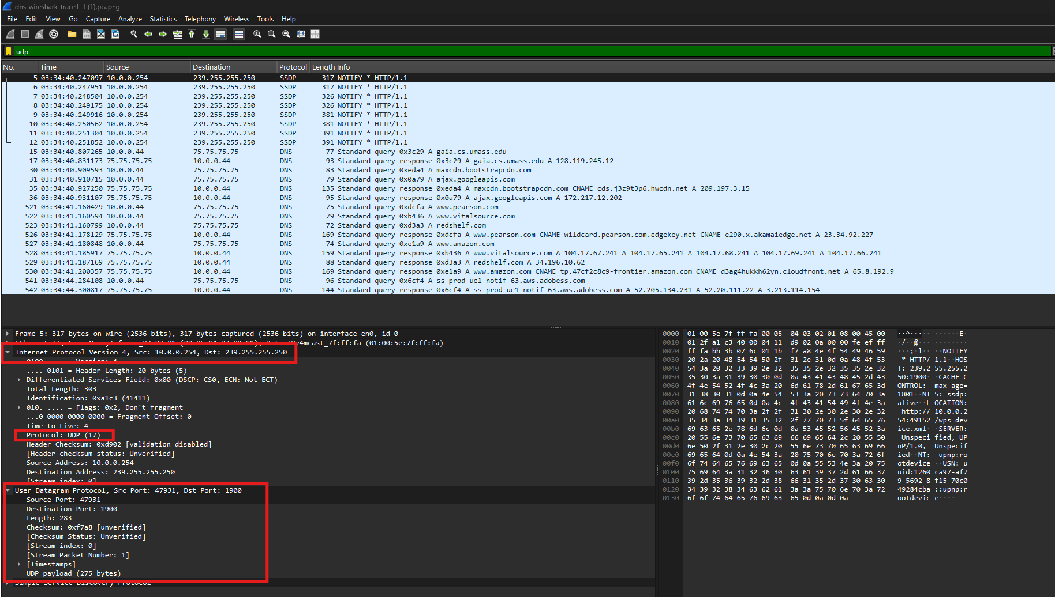
- By consulting the displayed information in Wireshark’s packet content field for this packet (or by consulting the textbook), what is the length (in bytes) of each of the UDP header fields?
Answer: There are 2 bytes for each UDP header field.
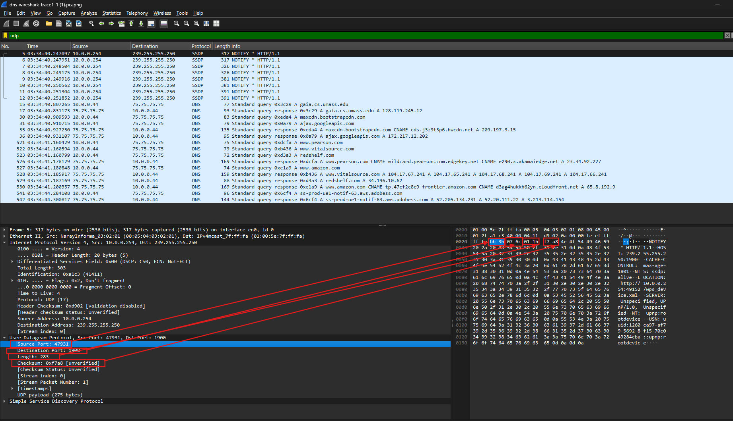
- The value in the Length field is the length of what? (You can consult the text for this answer). Verify your claim with your captured UDP packet.
Answer: The value in the length field is the length of UDP payload and UDP header field: $275+2+2+2+2=283$
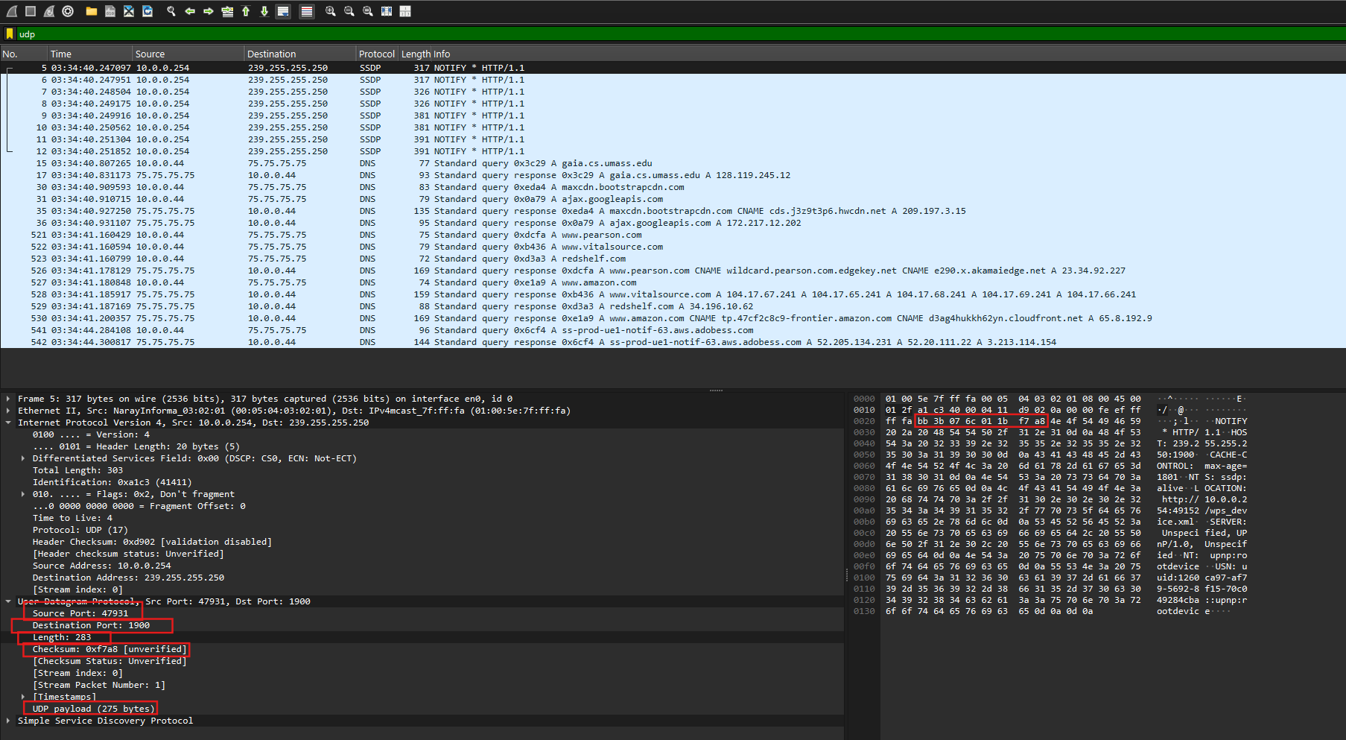
- What is the maximum number of bytes that can be included in a UDP payload? (Hint: the answer to this question can be determined by your answer to 2. above)
Answer: Because 2 bytes = 16 bits long, i.e., maximum length is -1 = 65535 bytes. But we also need 20 bytes for the IPv4 header and 8 bytes for UDP headers so maximum number of bytes: 65535 – 20 – 8 = 65507 bytes.
- What is the largest possible source port number? (Hint: see the hint in 4.)
Answer: As in question 4, Source Port field = 2 bytes=18 bits, and highest possible source port:$2^{16}$ -1 = 65535.
- What is the protocol number for UDP? Give your answer in decimal notation. To answer this question, you’ll need to look into the Protocol field of the IP datagram containing this UDP segment (see Figure 4.13 in the text, and the discussion of IP header fields).
Answer: The protocol number for UDP is 17
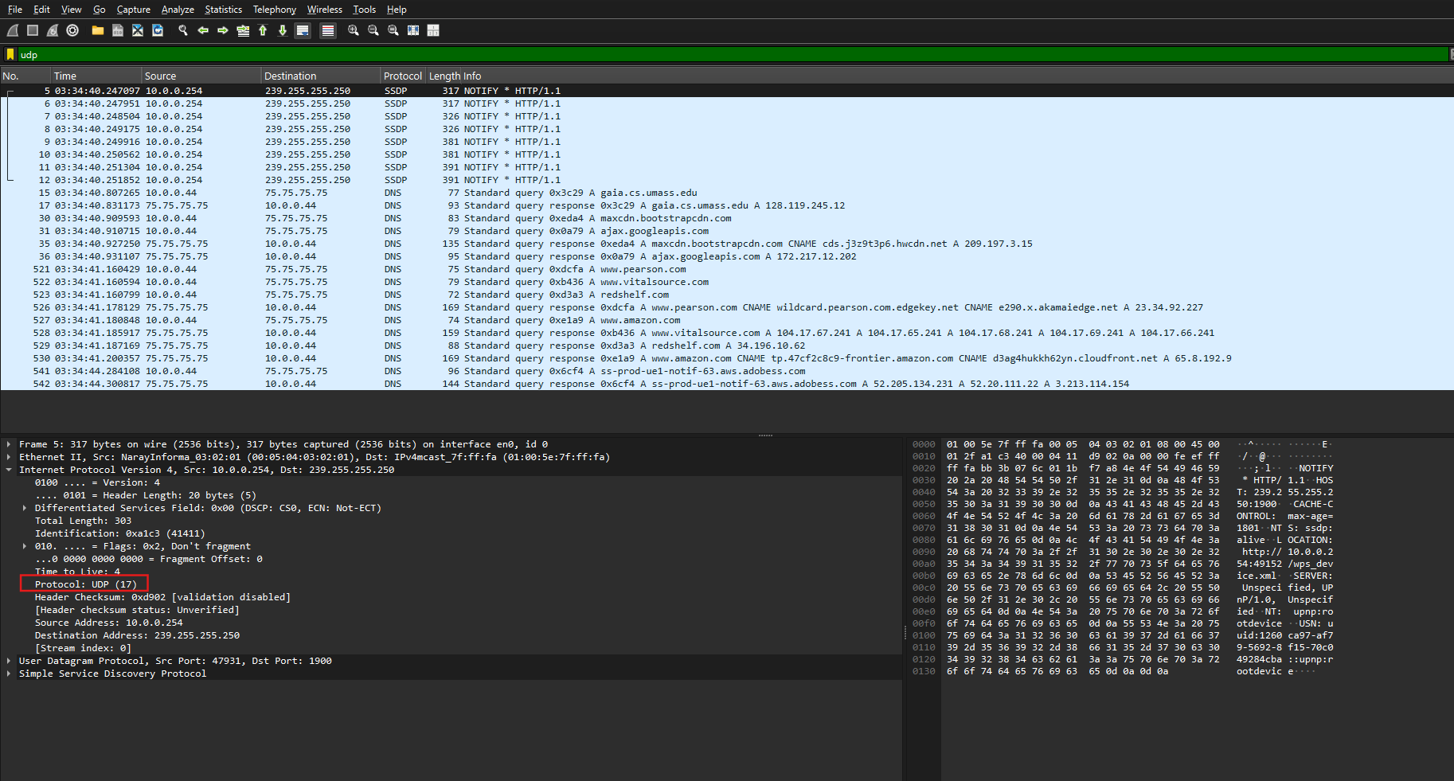
- Examine the pair of UDP packets in which your host sends the first UDP packet and the second UDP packet is a reply to this first UDP packet. (Hint: for a second packet to be sent in response to a first packet, the sender of the first packet should be the destination of the second packet). What is the packet number of the first of these two UDP segments in the trace file? What is the value in the source port field in this UDP segment? What is the value in the destination port field in this UDP segment? What is the packet number of the second of these two UDP segments in the trace file? What is the value in the source port field in this second UDP segment? What is the value in the destination port field in this second UDP segment? Describe the relationship between the port numbers in the two packets.
Answer: The packet number of the first UDP segment in the trace file is 15, the value in the source port field is 58350, and the destination port is 53.
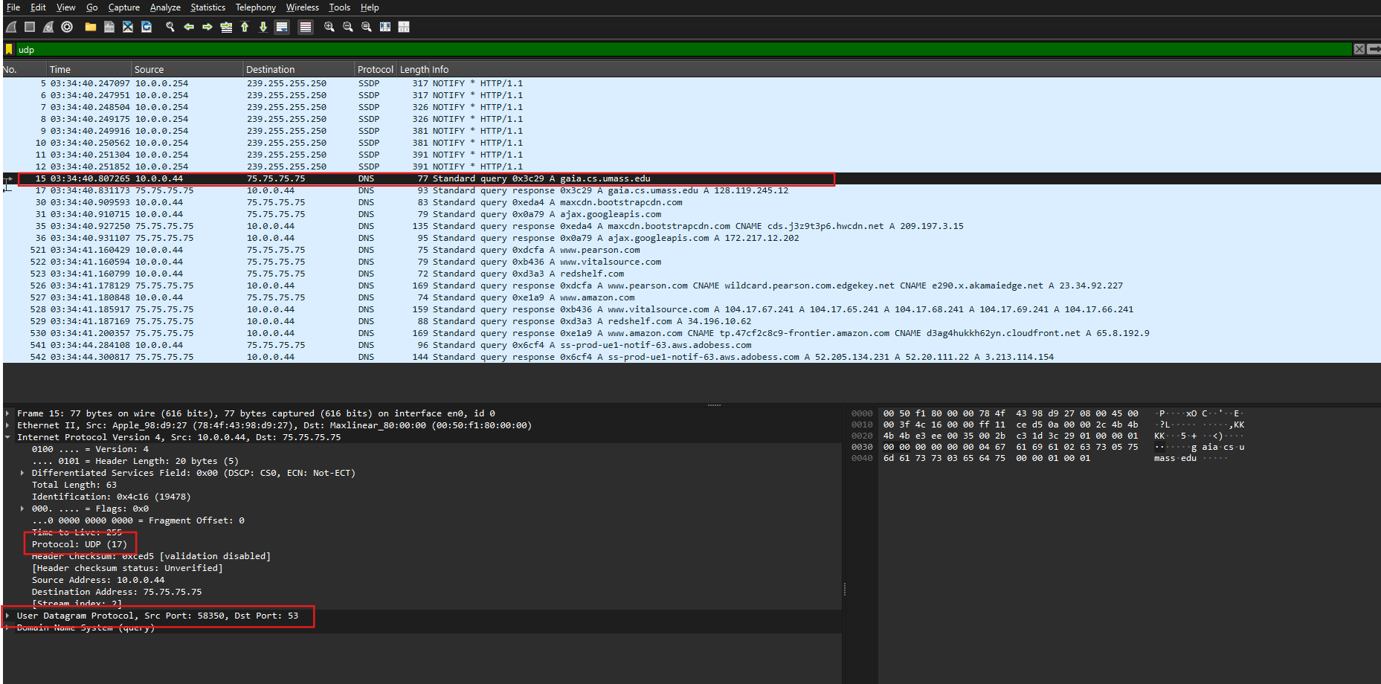
Answer: The packet number of the second UDP segment in the trace file is 16, the value in the source port field is 53, and the destination port is 58350.

